Assessment Schedule – 2012
Mathematics and Statistics: Investigate relationships between tables, equations and graphs (91028)
Evidence Statement
Question | Evidence | Achievement | Achievement with Merit | Achievement with Excellence
NØ no evidence (towards the standard)  N1 some evidence  N2 1 of u |  | A3 2 of u  A4 3 of u | M5 1 of r and 2 of u  M6 2 of r | E7 1 of t and 1 of r  E8 2 of t
ONE  (a)(i)  (ii) | $15  P = –15n + 95 | No alternative.  OR  Error with either the gradient or the intercept. | Equation correct.
(iii)(1)  (2) | n = 3 and n = 4 both have the same value of P.  OR the point translates up $15 for n = 4.  AND then continues with the same gradient.  From the fourth week  P = –15n + 110  (or equivalent equation).  Consistent with candidate’s interpretation of “what happens next”. | Incomplete description.  OR  Incomplete equation, ie gradient / intercept correct  OR  Changes plotted on graph  Consistent. | Complete description.  OR  Equation correctly given.  Consistent. | Complete description  AND  Equation correctly given.  Consistent.
(b)(i) |  | Table completed – accept one error.
  1 | 8
  2 | 27
  3 | 64
  4 | 125
(ii) | Consistent* points added to graph.  *Curve should still be similar to original. | Graph completed:  Accept discrete points  OR smooth curve;  (0,0) included = MEI.
(iii) | n³ is one place to the right of n³ +3n² + 3n + 1 | “Higher than” or” moved up”.  OR  Different y-intercepts:  0 and 1. | Description involving translation given.
(iv) | Difference is:  (n+1)³ – n³ or 3n² + 3n + 1  The vertical distances between the points on the graph. |  | A correct algebraic expression.  OR  description given. | A correct algebraic expression  AND  description given.

Question | Evidence | Achievement | Achievement with Merit | Achievement with Excellence
NØ no evidence (towards the standard)  N1 some evidence  N2 1 of u |  | A3 2 of u  A4 3 of u | M5 1 of r  M6 2 of r | E7 1 of t  E8 2 of t
TWO  (a)(i)  (ii) | 5c or $0.05  D = 0.05n + 5 | Payment calculated.  OR  Incomplete equation, ie gradient / intercept correct  OR  Consistent equation. | Correct equation.
(b)(i) | Graph drawn from table.  If graph is drawn from the WORDS of the question, or a mixture of the information from words and table, fixed amount could be $7 or $11, and a part-bundle –delivery could count! | Linking table to graph for ONE section as a straight line.  OR  Set of points.  (From either step end.)  OR  Step function with no change evident @ 300. | Graph shows change after 300 leaflets with: TWO sets of points.  OR  TWO straight lines. | Graph drawn as step function with distinction made after the 300 leaflets have been delivered.
(ii) | $4 (from table only)  OR $5.40 ($27 ÷ 5)  OR $6.75 ($27 ÷ 4) | Correct difference
(iii) | From table: Both get $36.  $36 ÷ 301 ≈ 12c a leaflet  $36 ÷ 349 ≈ 10c a leaflet  It is because the payments are for the delivery of the same number of whole bundles.  OR  From context wording:  See above  Both get an initial $11 or $7  + 5 or 6 bundles @$5 → $41 | Some reasoning provided which may include ONE calculation.  Allow other reasonable interpretations of the situation in this question. | Both amounts per leaflet calculated.  OR  A logical reason provided. | Logical reason.  AND  Supported by calculations.
(c) | - Leaflets from Us graph starts with a lower fixed payment ($5) than Leaflet Delivery Co ($11 / $7).  - Leaflets from Us payment per leaflet is less so their graph rises less steeply than that of Leaflet Delivery Co.  - Leaflets from Us payment is made per leaflet, → the increases are small and frequent making the graph look linear, whereas Leaflet Delivery Co payments are only made after each bundle of 50 leaflets so the graph is a step function, with jumps in payment showing up, every 50 leaflets. | Partial comparison of the two graphs, eg the different intercepts on the vertical axis.  OR  The different rates of increase shown by the graphs.  OR  The different shapes of the graphs. | Describing TWO differences between the two graphs in context. | Describing the differences between the two graphs in context including an explanation of why it is a step function and how this arises.
(d) | y = –(x + 2)(x – 4)  OR y = –(x – 1)² + 9  OR y = –x² + 2x + 8 | One error in equation. | Correct equation.

Question | Evidence | Achievement | Achievement with Merit | Achievement with Excellence
NØ no evidence (towards the standard)  N1 some evidence  N2 1 of u |  | A3 2 of u  A4 3 of u | M5 1 of r  M6 2 of r | E7 1 of t  E8 2 of t
THREE  (a)(i) | Graph drawn | Graph correct.  Ie parabolic features are sufficiently evident in a smooth curve.
(ii) | (0,0) and (–2,0) | Both coordinates correct.
(iii) | Graph drawn | Vertex correct  (or intercept correct). | Graph correct.
(iv)  (v) | The graph has changed position: three units to the right and up 4 units.  In the equation, 3 is subtracted from the “x’s” and 4 is subtracted from the “y”. | Description of ONE of the changes relating to either:  The position of the graph.  OR  How it is shown in the equation. | Full description of :  Changes to the graph.  OR  Changes to the equation. | Full description of:  The translation of the graph.  AND  The changes to the equation.
(b)(i) | 6 m | Correctly finds height.
(ii) | Correct plot of graph through (0,6), (2,2) and (4,6).  Poles shown at x = 0 and  x = 4. Position of poles could be implied by the domain used for the graph. | Graph correctly drawn.  OR  Lines for both poles drawn / implied, by the domain used. | Poles correctly shown to give symmetrical shape, over the domain  0 < x < 4.
(iii) | y = ax(x – b) + c  y = ¼ x(x – 8) + 5  OR y = a(x – b)² + c  y = ¼ (x – 4)² + 1  OR y = ax² +bx + c  y = 0.25x² – 2x + 5 | General form of equation evident, with one of a, b, c correct. | Equation given with one of the constants: a, b, c incorrect. | Correct equation.

Graphs for a(i) b(ii)
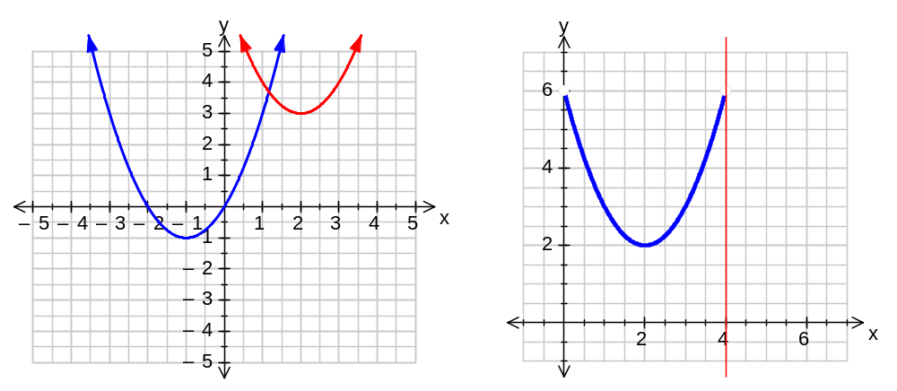

Graphs showing for Question Two b (i)
Achieved evidence Merit evidence Excellence
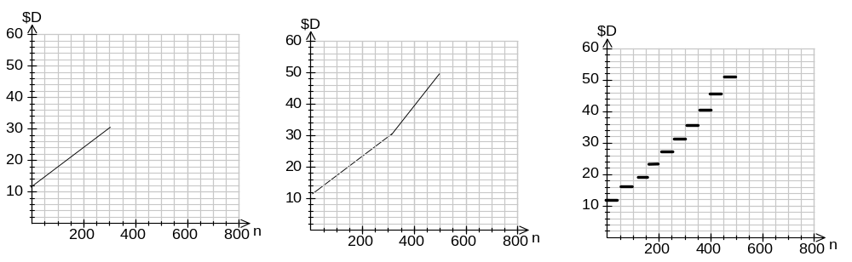 one section both sections, showing the change both sections, showing the change AND a step function used
OR
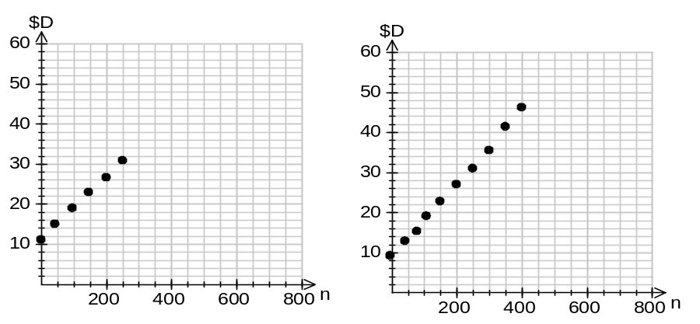
one section both sections, showing the change

OR
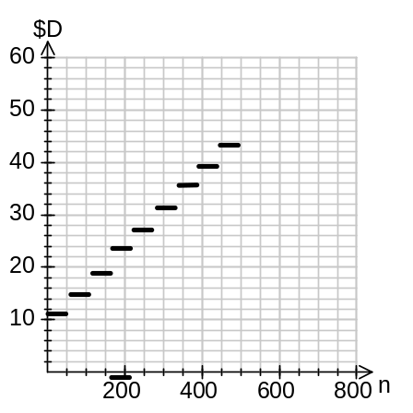
Step function with NO change.

Judgement Statement – 2012
 | Not Achieved | Achievement | Achievement  with Merit | Achievement  with Excellence
Score range | 0 – 8 | 9 – 14 | 15 – 18 | 19 – 24

